# Company form – Placement Provider Form

## Introduction

## Input Types

### Basic Text Input Field

### Drop Down Selection List

### Date Answer field

### Number Selector

## Different types of Sections

# Introduction

This feature has been created to allow companies to enter details about the student application they have received as requested by the university. The **Placement Provider Form.**

The Placement Provider Form has the same style throughout, and split up into sections to contain certain focuses within a page then move on to the next section.

The form has the same consistent design as shown below:

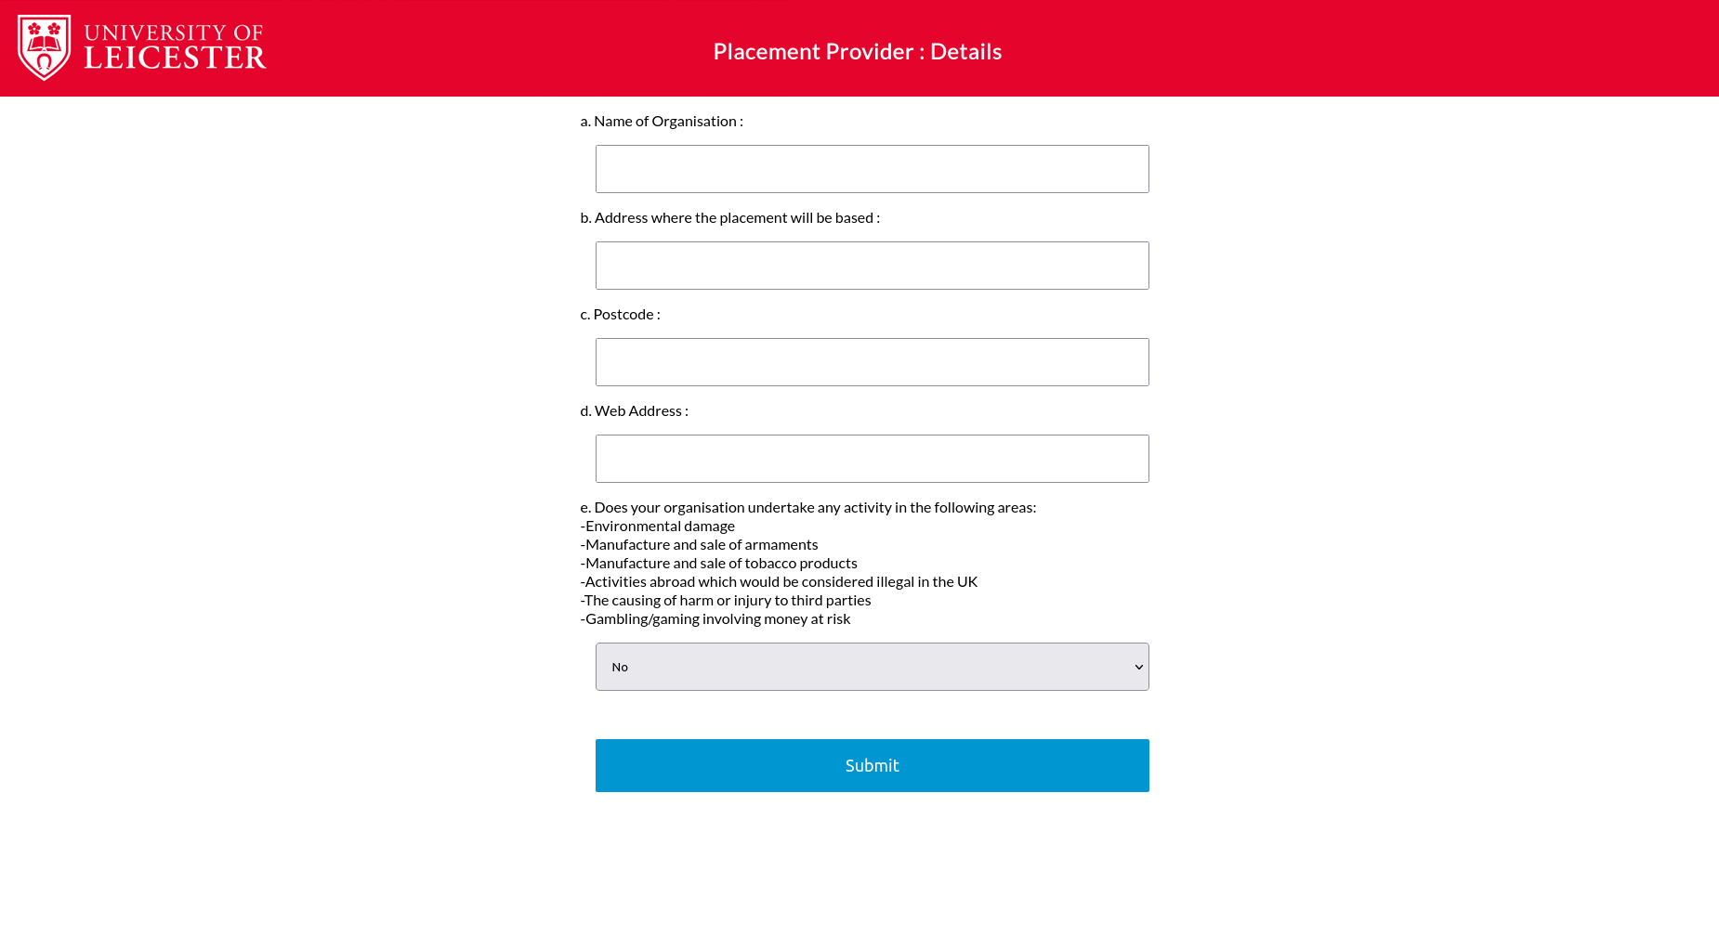

Placement Providers can enter their details in the input boxes shown, by entering the detail the form asks for right above it, or by clicking on the box for some questions, where a drop down menu will be shown, so the placement provider can select possible answers. You can see if it is a drop down question by the arrow shown on the right of the box, as shown in the above screenshots in question “e”

To move onto the next section of the form, the blue submit box shown in the above screenshot is a button that should be pressed when the form fields have been completed.

If placement providers do not correctly fill out the necessary fields, or omit them, errors will be shown in a red font (shown below) and stop the placement providers from being able to proceed to the next section unless they enter what the form is asking for.

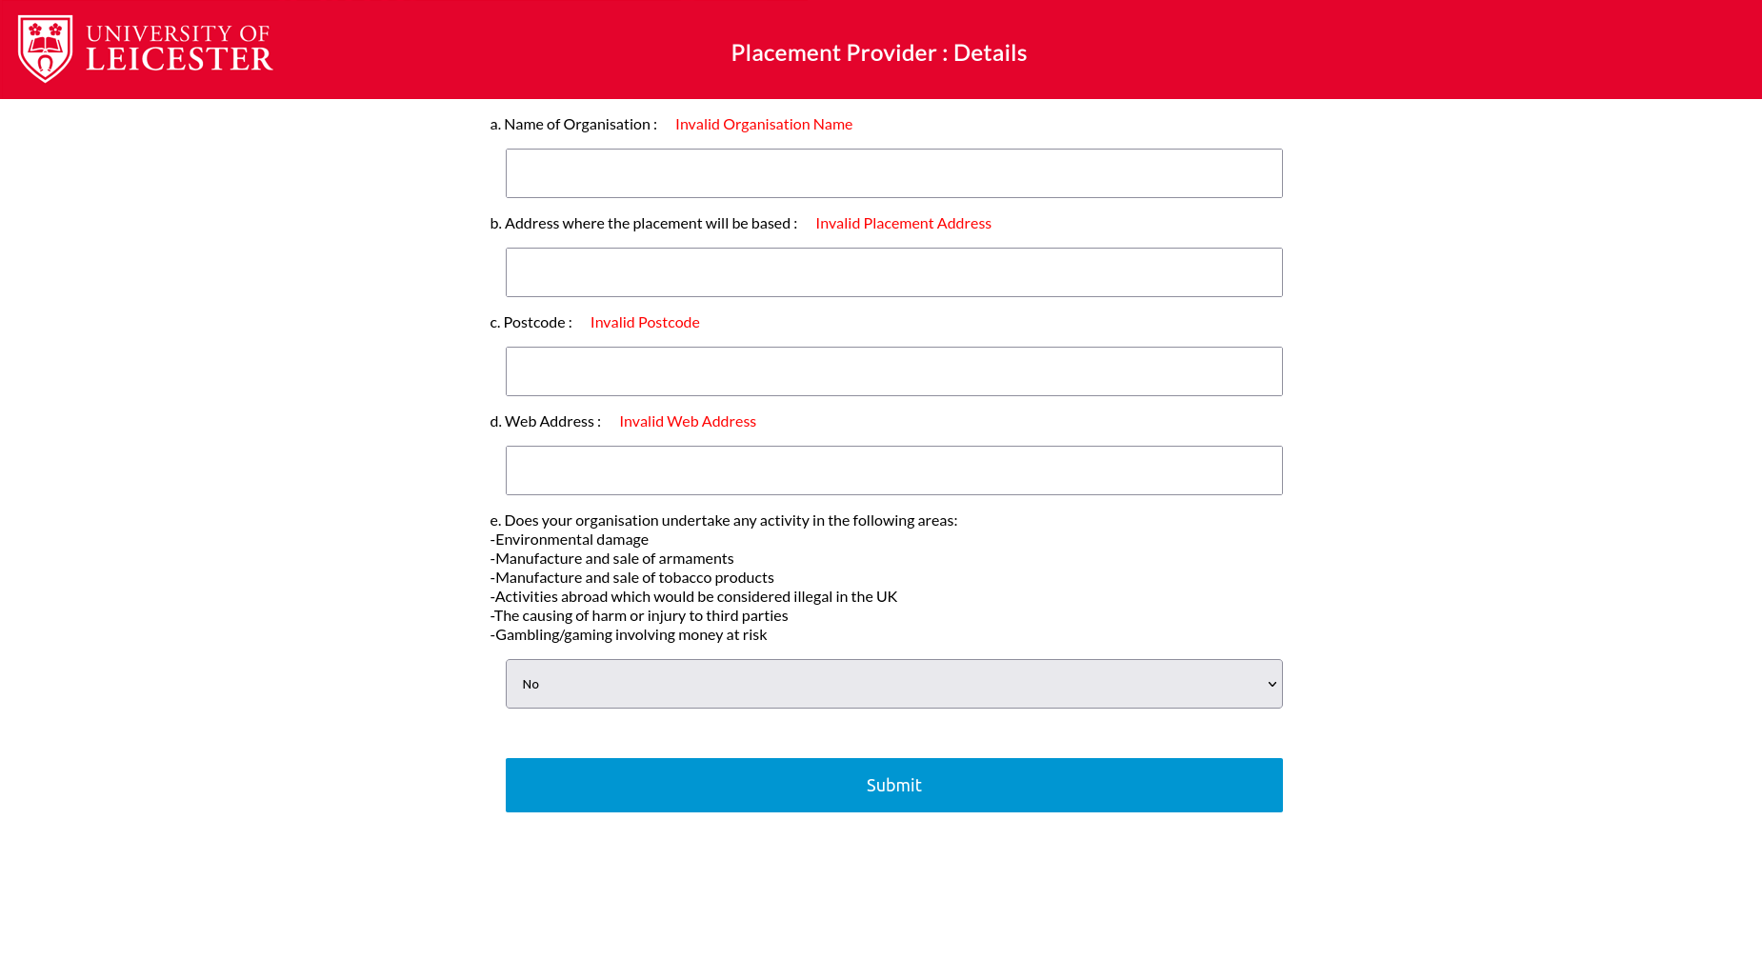

When the Placement Provider has filled out the forms correctly, they can navigate to the next section by the blue submit button, where the next section will be shown:

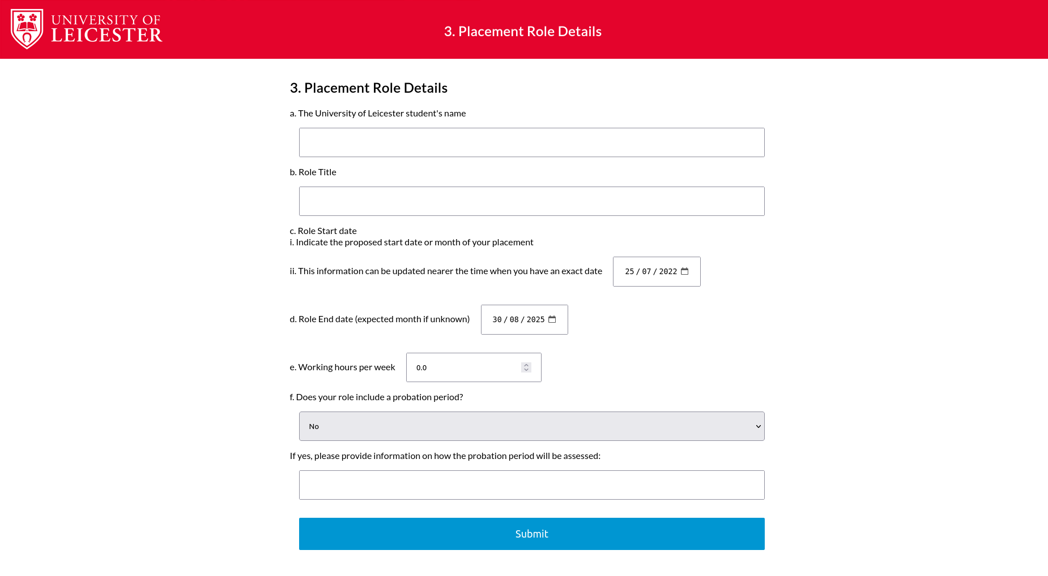

This pattern and style is followed until the end of the form, which is shown with a Thank You page:

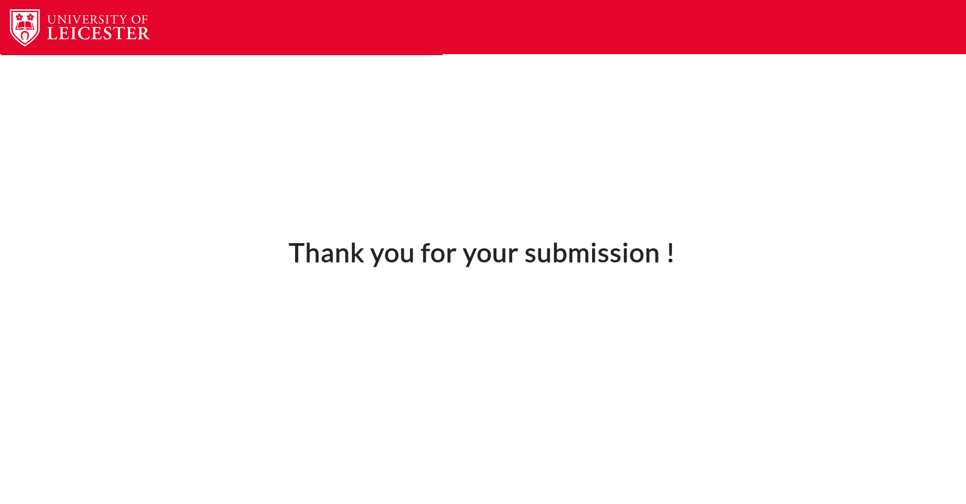

# Input types

## Basic Text Input Field

In the above screenshot, you can see what the form is asking for “Name of organisation”, and that there is an empty white box below, with no icons on it. This is a simple input box, where you click on the box and type in the details.

## Drop down selection list

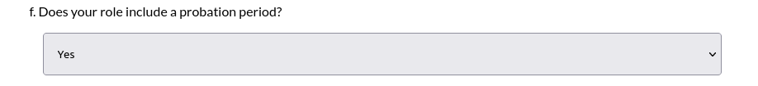

In the above screenshot, you can see that this white box has a downwards pointing arrow on the right side of the box. This signifies that the field is a drop down selection list. The user needs to click on the box where the rest of the options are shown like so:

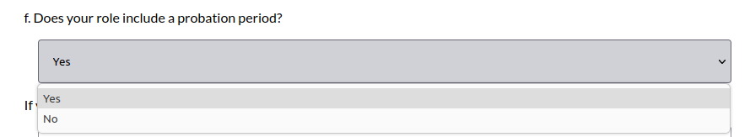

Then the user can select the option they wish as their answer.

## Date answer field

This type of question shows that we have to enter a specific input that is a Date. There are 2 ways a

user could enter their answer. They could click directly on the numbers and enter their answer by using their keyboard to type that values in:

Or they could click on the Calendar icon on the right of the box and select their date from the

calendar grid format shown:

## Number Selector:

Another type of user input is a number selector:

If the user hovers their mouse cursor over the field you can see some arrow selectors appear:

The user can provide their answer in 2 ways.  
One is by clicking on the number and entering their value on their keyboard.

Another is by using the arrow selector to increment/decrement the value (please note giving a negative answer where not appropriate will raise an error that stops you from proceeding).

# Different Types of Sections

There are 11 main sections of the Placement Provider Form. They are:

Placement Provider Details, Placement Role Details, Placement Provider Named Contact, Placement Provider Work Factors, Placement Provider Other Factors, Placement Provider Policies and Insurance UK, Placement Provider Policies and Insurance Overseas, Placement Provider Health & Safety, Placement Provider University Access, Placement Provider Declaration.

Placement Providers need to fill them out so that the details are received by the Placement Team who will proceed with the process of carrying out a risk assessment of the placement provider, and provide the student with an acceptation or a rejection.